Derek McCammond

CS 570

Homework Assignment #1

**1a:** (Hand-drawn in MSPaint)

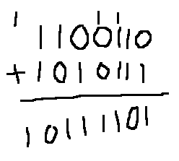

Answer: 10111101

**1b:** (Hand-drawn in MSPaint)

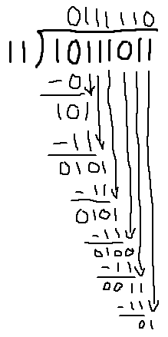

Answer: 0111110 residue 1

**2:**

In the ASCII format, each character can be represented as one byte. Given a fifteen-page document with each page having two-hundred words and an average word length of five characters with spaces in between, each page would require roughly 1000 bytes for the words and 199 bytes for the space characters for a total estimate of 17,985 bytes required to store the entire document in memory.

Words: 200 x 5 = 1000 bytes

Spaces: 199 x 1 = 199 bytes

Pages: 15

(Words + Spaces) x Pages = **17,985 bytes**

**3:**

T1 = P ˄ ¬Q T2 = P ˅ Q T3 = T1 ˅ T2

|  |  |  |  |  |
| --- | --- | --- | --- | --- |
| P | Q | T1 | T2 | T3 |
| T | T | F | T | T |
| T | F | T | T | T |
| F | T | F | T | T |
| F | F | F | F | F |

**4:**

T1 = ¬P ˅ ¬Q T2 = R ˄ Q T3 = P ˄ ¬R T4 = T2 ˅ T3 T5 = T1 ˄ T4

|  |  |  |  |  |  |  |  |
| --- | --- | --- | --- | --- | --- | --- | --- |
| P | Q | R | T1 | T2 | T3 | T4 | T5 |
| T | T | T | F | T | F | T | F |
| T | T | F | F | F | T | T | F |
| T | F | T | T | F | F | F | F |
| T | F | F | T | F | T | T | T |
| F | T | T | T | T | F | T | T |
| F | T | F | T | F | F | F | F |
| F | F | T | T | F | F | F | F |
| F | F | F | T | F | F | F | F |